**Bell Ringer**: Meiosis Diagrams

*AP Biology*

**MEIOSIS I:**

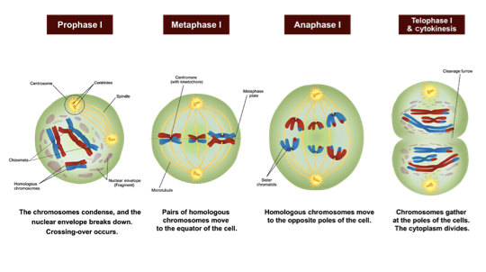

**What is the Purpose of Meiosis I:**

**MEIOSIS II:**

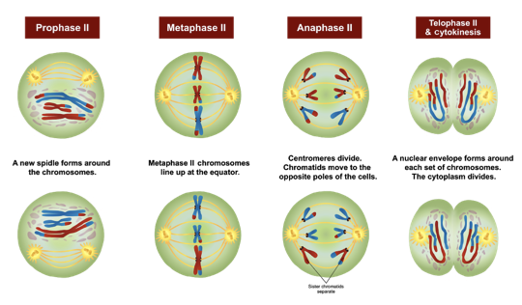

**What is the Purpose of Meiosis II:**

**What are the Major events of Meiosis II:**